**LKSC702 AT850C**

**IPD & AST:**

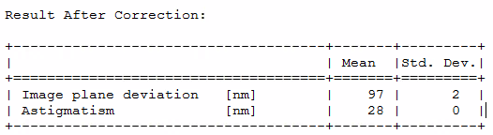

**Uniformity LUSU ATP setting**

**Straylight At Multiple Opaque Squares**

**FXY**

