K703 AT850D
IPD & AST:
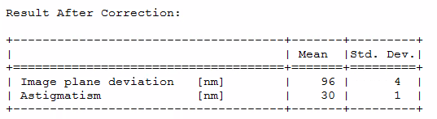

Uniformity LUSU ATP setting
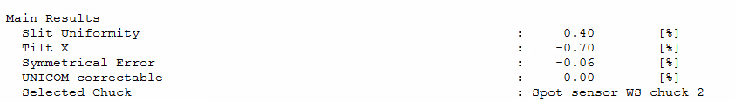

Straylight At Multiple Opaque Squares
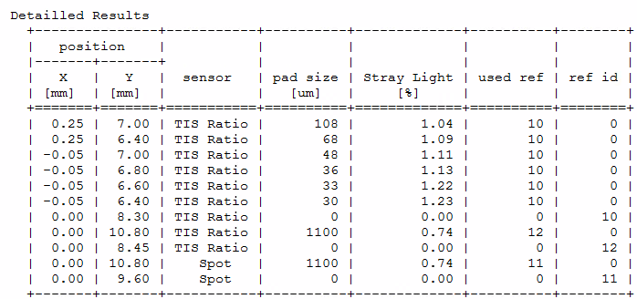
FXY
